Modifying Reports for Bottom 30% Demographics
- Access your Top / Middle / Bottom Demographic by clicking on Students and then Demographics.
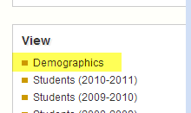
- Select the year your demographic was created and click “Search”.
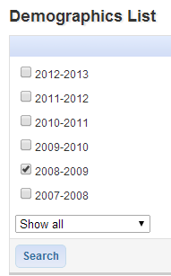

- After clicking on your demographics’ title, click “Make this a Report”.
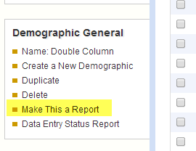
- Select Refine Data Set
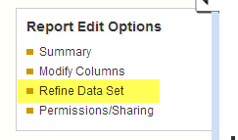
- Select Click here to Further Refine Your Data Set
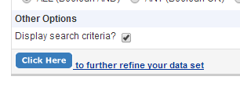

- Select Demographics, the year your demographic was made, and then your demographic title.
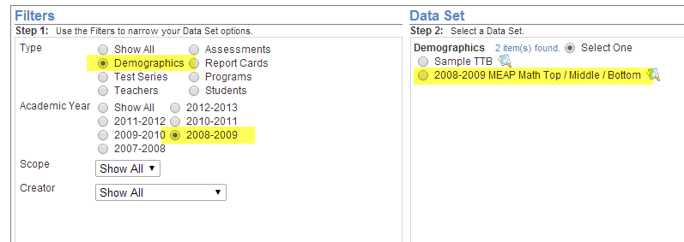
- Select Next Step.
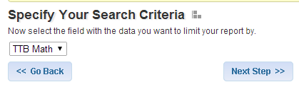
- Select Next Step.
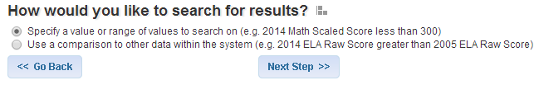
- Select 3 and click Next Step.
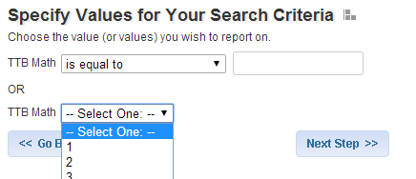
You have now refined your report so that only the kids with a “3” are showing.
- Navigate to your assessment, select a report, and click Modify This Report.
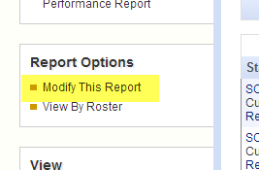
- Select “From Report”, select the TTB report, select the Report Type, and select the assessment (you may need to check the Show All Assessments box). Click Submit.
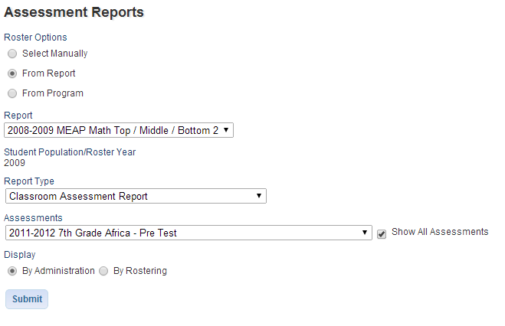
Your data now shows results for only the students in the TTB Report who had a 3.

