Creating a Top 30% and Bottom 30% Demographic in DataDirector
Many schools are looking for ways to close the achievement gap between the top 30% of performers and the bottom 30%. One way to do this is to first identify your top 30 and bottom 30, then put this list into DataDirector as a demographic. This will allow educators to view their local assessment data for either the top 30 or bottom 30. In other words, you’ll be able to track the achievement gap within local assessments, making it easier to monitor the size of this gap.
- After running the MEAP Scaled Scores Report and identifying students who are in the Bottom 30%, place a 3 next to their names. Place a 2 next to the Middle 40% and a 1 next to the Top 30%.
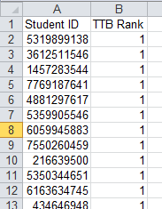
- Remove all data except for the Student ID. Save the file as a Text (Tab delimited) file.
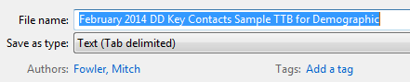

- In DataDirector, head to the Student section and click on Demographics.
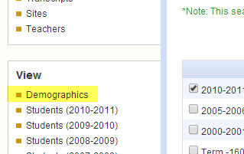

- Click Create a New Demographic
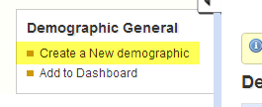
- Enter the Summary data for the demographic (title, academic year, scope, and number of fields). I selected number of fields because I am only going to upload their TTB rank (1,2, or 3).
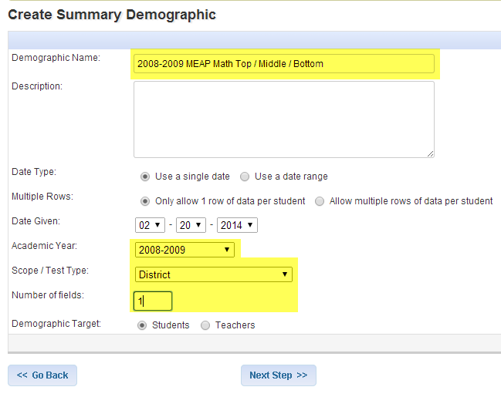
- Name the field.
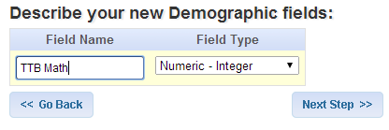
- Select Import Data.
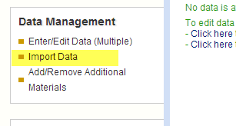

- Click “Choose File”, select your file, and click Upload File Now.
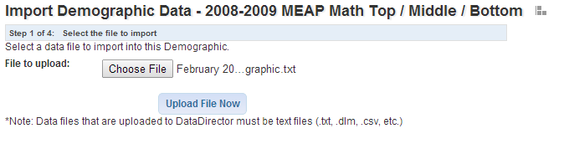

- Click Next.
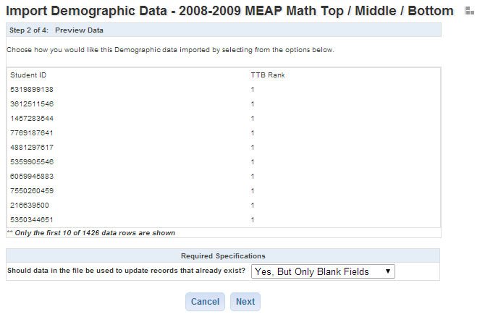
- Use the dropdown menu to map the second column to TTB Math. Click Next.
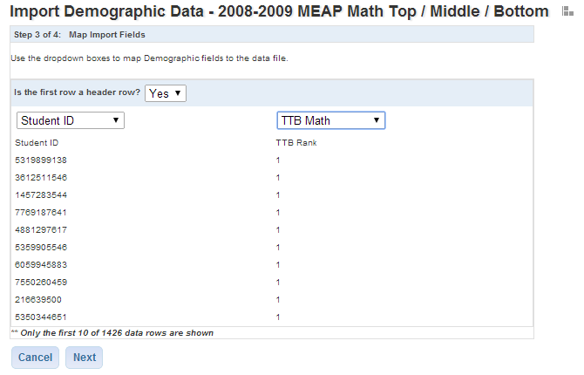

- Click Next.
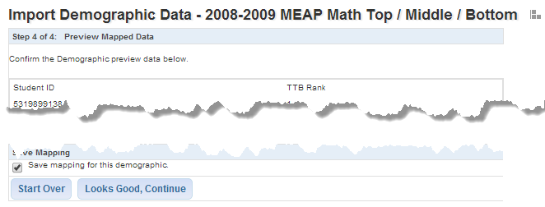
You have now created your Top, Middle, and Bottom demographic.

