Identifying a Preliminary Bottom 30% in DataDirector
- Run the MEAP Scaled Score Report and Download to Excel
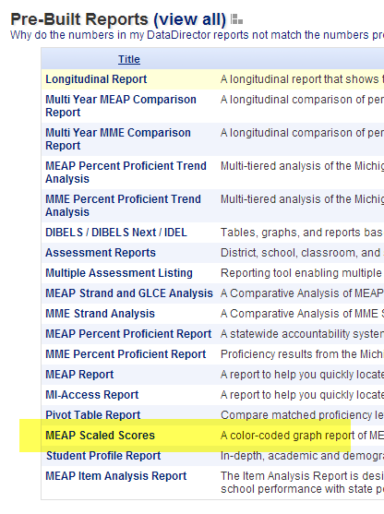
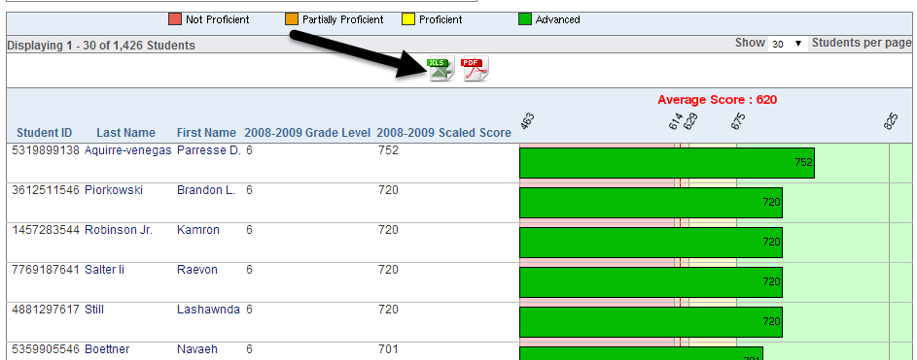

- Determine what 30% of the student population is. In the report above, I have 1,426 students. .30 x 1,426 = 427.8. Therefore, the lowest 427 students are my Bottom 30% within this subject area. Notice that Excel counts the number of rows I’ve highlighted. This can help save time when counting out the number of students in the Bottom 30%.
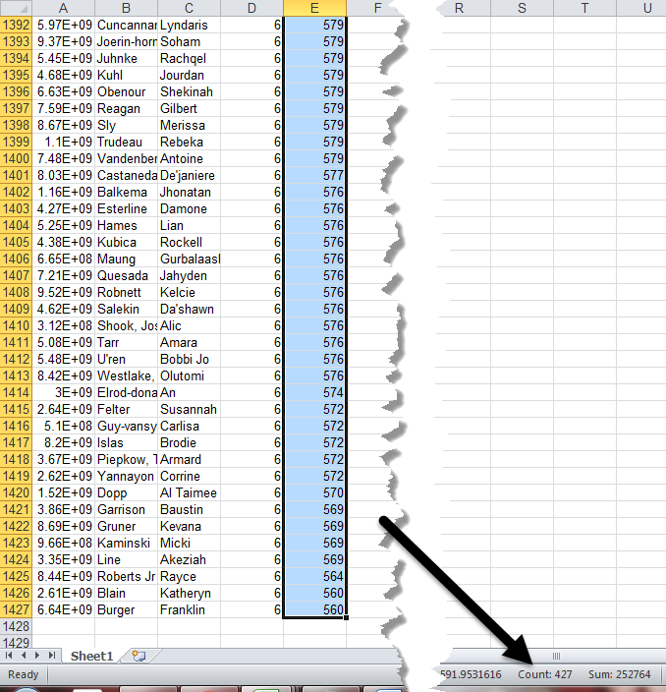
I now have my preliminary Bottom 30%.

