Importing Data From DataDirector Into Skyward
After administering and analyzing data within DataDirector, many teachers would like to import the overall score into Skyward for reporting purposes. This tutorial explains how to take data from DataDirector and import it into Skyward.
- Select Summary Assessment
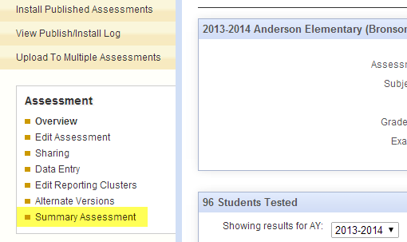
- Select “Make This a Report”
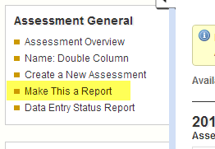

- Select Modify Columns
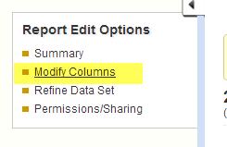
- Select “Click Here to Add Another Report Column
- Select Demographics and then General Demographics
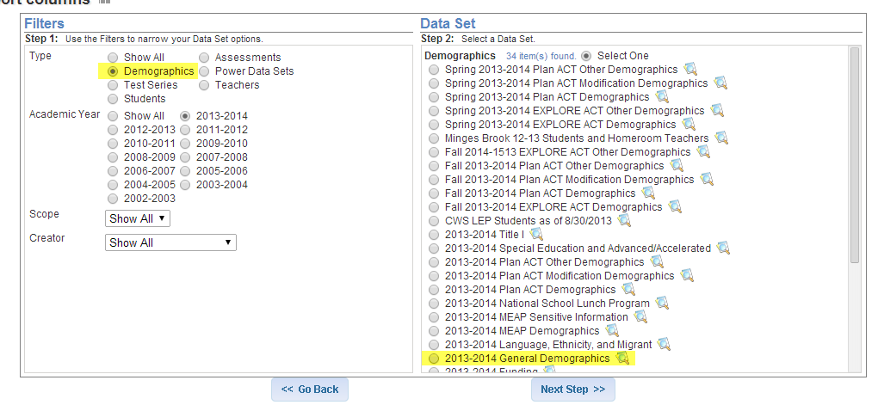

- Select Local Student ID and Click “Next Step”
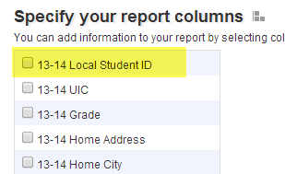
- Select Modify Columns

- Rearrange Columns
  - When importing data, the format should be Last Name, First Name, Local Student ID, Total Score.
  - Identify the column that contains the overall score you’d like to import. Label that column Total Score.
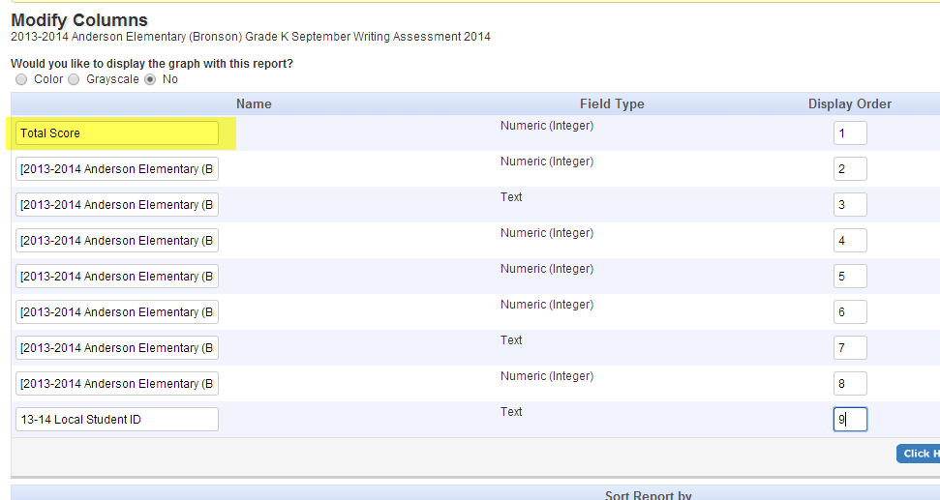
  - Identify the column that contains the local student ID. Label that column Skyward ID.
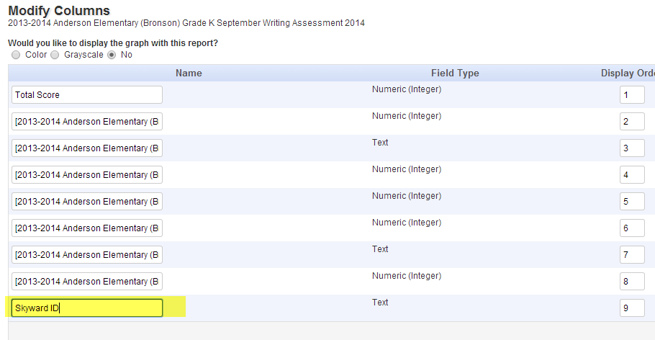
  - Delete the remaining columns.
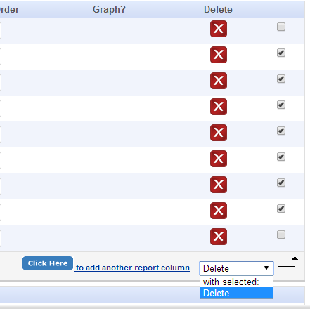
  - Reorder the columns so that Skyward ID is in position 1 and Total Score is in position 2.
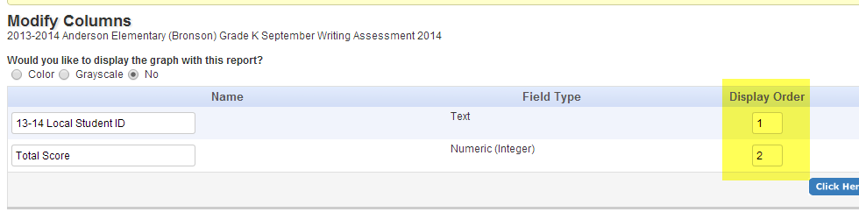
- Select the Excel Icon
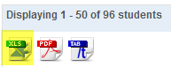
- Select “Click Here”
- Select the Excel Icon
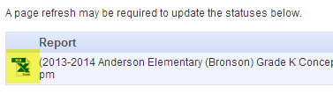
You now have an Excel file that you can import into Skyward. For the remaining steps, please click the link below and being watching at the 8:50 mark.
http://youtu.be/vqnDnuEp9PE?t=8m54s

