Granting Access on the BAA Secure Site
What does the person requesting access see when they request access?
- Those requesting access click Security and then Request Access.
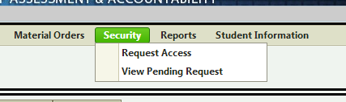’
- Next, users select the Role, ISD, and District, then click Request BAA Access.
At this point, the District Administrator will receive an email saying “you’ve received a request for access.” This is their heads up that there are pending requests.
What will the District Administrator need to do with the request?
- Click Security > View Pending Request to see the requests.
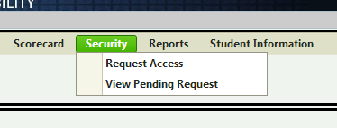

- Click Search to see all of the request that are pending.
- You will see each person who has requested access. Click View Access Request to proceed.
- At this point, you will want to select Approve (if you deem the request appropriate).
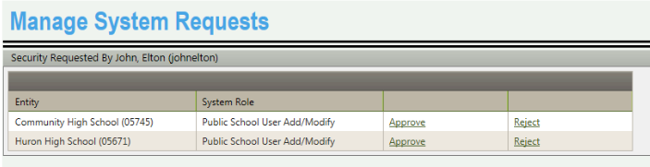

- Next, the Add User Security will be displayed. At this point, you will be able to use the “Select Profile” dropdown menu to select the user’s profile.
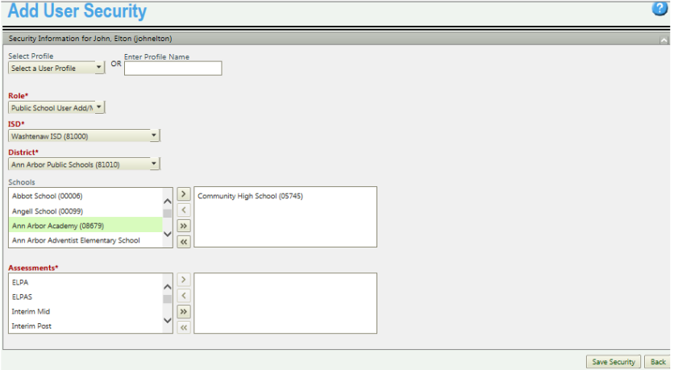
In addition, you will need to select a Role (this will default to what role was requested). Select the ISD, District, and Schools (if necessary). Finally, select the button to provide the requestor with access to all assessments.
At this point you have granted access to the individual requesting access. In some cases, you may need to add additional roles to a user’s profile. For example, this may happen if a user is a principal, but also needs “School Accountability” access in order to view and appeal the building’s scorecard.
Adding Additional Roles to a User
- Select Admin Functions > Security – Manage User Profiles
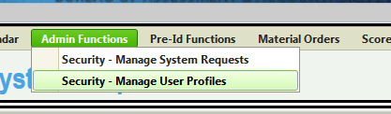

- Click Search to view all users.
- Select Update Security
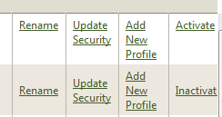
- Select your new role, ISD, District, and Schools (if appropriate). Select the button to move all assessments to the right. Click Save Security.
