Demystifying DataDirector – BCPS Activity Guide
Activity: How are students doing?
It is expected that administrators will answer the question “How are students doing?” Describe what an administrator might see or hear from a teacher that successfully answers this question. What might you do or say to answer this question?

Activity: Accessing Assessment Reflection
Based on the information you’ve just received in regards to accessing assessments and assessment calendars, what lingering questions might you have about this process as it relates to your role? For teachers’ roles?

Activity: Assessment Reports Overview
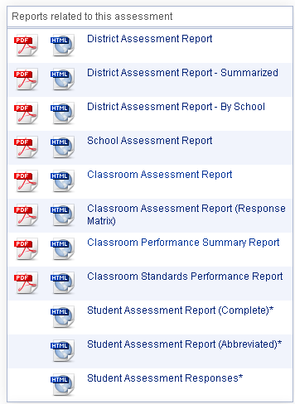
Mitch’s Recommendations
D = Recommended District Report
S = Recommended School Report
C = Recommended Classroom Report

The _______________ Report is ideal for secondary teachers looking to compare various periods.

The _________________ Report is ideal for data conferences and teachers looking to view classroom data with student names.

Activity: District Assessment Report
B
C
A

Description |  | Potential Use
A
B
C

The important thing to remember about performance bands is…
A
B
Description |  | Potential Use
A
B

C
B
A
Description |  | Potential Use
A
B
C

Activity: School Assessment Report
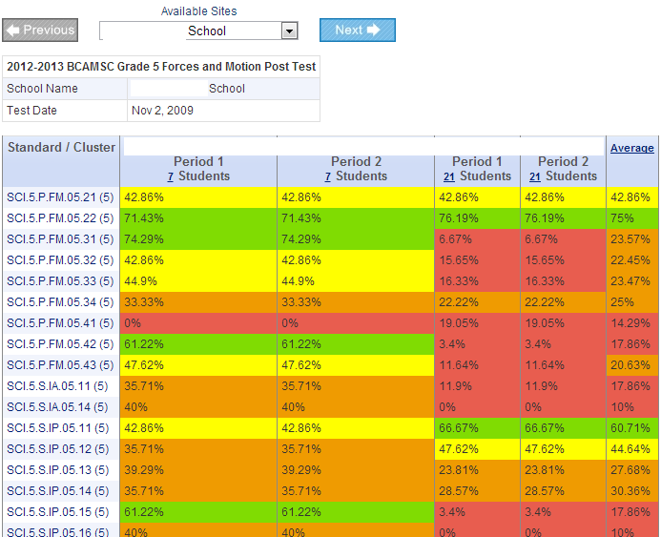
A School Assessment Report could be used for:

Activity: Classroom Performance Summary Report

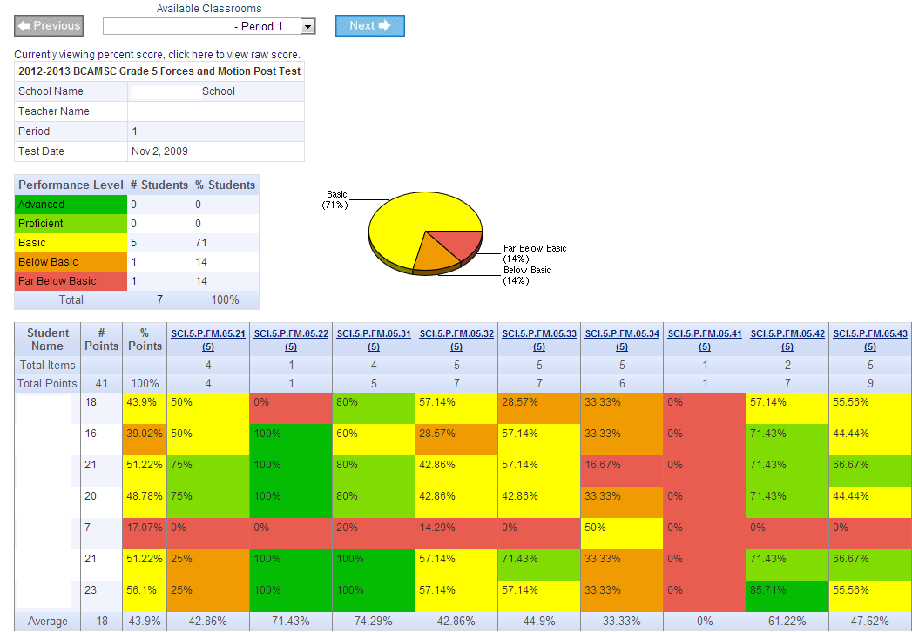
A Classroom Performance Summary Report could be used for:

Activity: Reports Reflection
What thoughts do you have on how you might utilize DataDirector Assessment Reports to analyze building data? How might you use these reports to analyze classroom data with teachers?

Activity: Dashboard Planning
Based on what you’ve learned about the DataDirector Dashboard, what widgets might you utilizes to help in answering the question “How are kids doing?”?

