Understanding Your Top From Your Bottom
Session Activities
Activity: Identifying AMOs
Using the AMO document on the Moodle site, identify the following Annual Measurable Objectives for your building or district:
Content  Area | Annual  Increment | 2011-12  Base Target | 2012-13  Target | 2013-14  Target
Mathematics
Reading
Science
Social Studies
Writing

Activity: Who are the Bottom 30%?
Using the “Download Student Information” link on the BAA Secure Site, select a grade level and subject area and identify one student from the Top 30%, Middle 40%, and Bottom 30%. Record the student below along with their Scaled Score, Z-Score, and Proficiency Label (Provisional, Not Proficient, Growth Proficient, Proficient).
Student Name | Top/Middle/Bottom | Scaled Score | Z-Score | Proficiency Label
 | Top 30%
 | Middle 40%
 | Bottom 30%

Activity: Revealing Proficiency
On the BAA Secure Site, navigate to a Scorecard and click on a subject area.
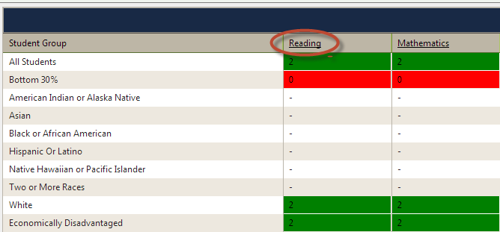
Within a subject area, click on “Proficiency”.
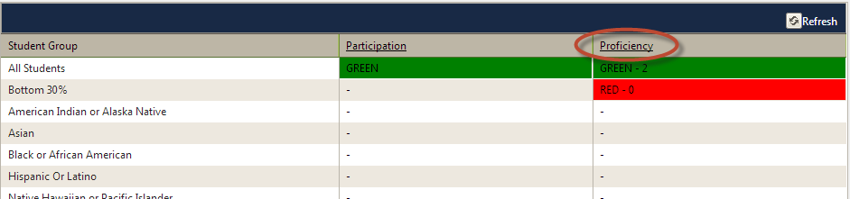
Within Proficiency, click on “Total Proficient”.
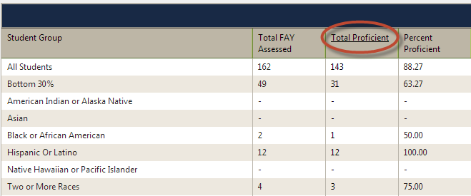

Review the Total Proficient data and respond to the questions below:
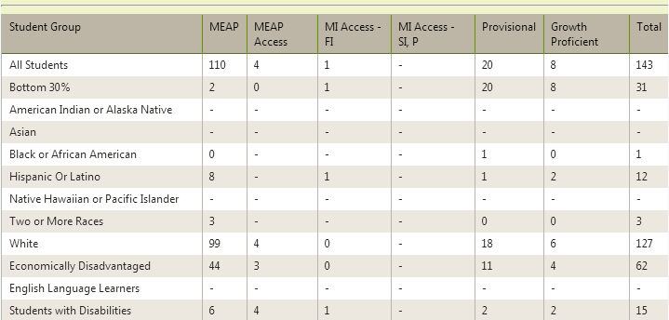
What percentage of All Students were proficient in MEAP according to what most educators consider “proficient” (receiving 1’s or 2’s)?

What percentage of All Students were Provisionally Proficient? What thoughts might you have about this number?

What percentage of All Students were Growth Proficient? What thoughts might you have about this number?

What percentage of students contributed to your district or school’s proficiency by taking an alternate assessment (MEAP Access / MI Access)?

Activity: Proficiency Audit
As we have discussed, your overall scorecard color is based on the percentage of points you earn minus the penalties assessed (audits). Let’s take a look at where your district or building lost points for proficiency.
Content  Area | All Students  (Did you receive full credit?) | Audit Reasons  (Why did you lose points?) | Sub Group  (Did you receive full credit?) | Audit Reasons  (Why did you lose points?)
Sample | Yes |  | No | Our bottom 30% and Economically Disadvantaged subgroups did not hit their AMO.
Mathematics
Reading
Science
Social Studies
Writing

Activity: Participation Audit
As we have discussed, your overall scorecard color is based on the percentage of points you earn minus the penalties assessed (audits). Let’s take a look at where your district or building lost points for participation.
Content  Area | All Students  (Did you receive full credit?) | Audit Reasons  (Why did you lose points?) | Sub Group  (Did you receive full credit?) | Audit Reasons  (Why did you lose points?)
Sample | No | We did not test 95% of our students. | No | We did not test 95% of our students with disabilities.
Mathematics
Reading
Science
Social Studies
Writing

Activity: Completion Rate Audit
As we have discussed, your overall scorecard color is based on the percentage of points you earn minus the penalties assessed (audits). Let’s take a look at where your district or building lost points for completion or attendance rate.
Accountability Area | All Students  (Did you receive full credit?) | Audit Reasons  (Why did you lose points?) | Sub Group  (Did you receive full credit?) | Audit Reasons  (Why did you lose points?)
Sample | Yes |  | No | We did not graduate 85% of economically disadvantaged students within the 4, 5, or 6 year cohort.
Completion Rate
Attendance Rate

Activity: Other Factors Audit
As we have discussed, your overall scorecard color is based on the percentage of points you earn minus the penalties assessed (audits). Let’s take a look at where your district or building lost points for completion rate or attendance rate.
Accountability Area | Points?  (Did you receive full credit?) | Audit Reasons  (Why did you lose points?)
Sample | No | We did not submit our evaluations document to REP in the correct format.
Educator Evaluations
Compliance Factors

Activity: Overall Scorecard Color
Using the Scorecard Decision Tree on the Moodle Site, determine why your district or building received their overall color. Provide a succinct narrative below describing why you received the color you did. Be sure to include the % of points earned and audits that impacted your color.
Overall % Points Earned
Audit Areas

We received an overall color of _________________ because:

Activity: Z Score Review
Utilizing the Top to Bottom Lookup Tool on the Moodle site, select a building within your district and complete the following:
- Highlight any Subject Area Z Score RED that is less than -0.5. These are areas where you have been ranked in the bottom 1/3 of the state.
- Highlight any Subject Area Z Score YELLOW that is between -0.5 and 0.5. These are areas where you have been ranked in the middle 1/3 of the state.
- Highlight any Subject Area Z Score GREEN that is greater than 0.5. These are areas where you have been ranked in the top 1/3 of the state.
- Of the RED subject area z-scores, determine which sub z-score (Achievement, Improvement, or Achievement Gap) is the furthest from the mean (most negative). What are your hunches about how you might improve this area?

