Granting Access on the BAA Secure Site for ISD Staff
In the near future, CISD staff will be requesting access to your data via the BAA secure site in order to provide support around Scorecards, MEAP/MME Data Analysis, and other pertinent topics. The process for granting access for ISD Staff take a few steps as the BAA site is new.
What does the CISD see when they request access?
- We click Security and then Request Access.
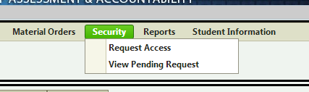’
- We select the Role (I will be selecting Accountability District to begin), ISD, and District. Then we click Request BAA Access.
At this point, the District Administrator will receive an email saying “you’ve received a request for access.” This is your heads up that there are pending requests.
What will you need to do with the request?
- Click Security > View Pending Request to see the requests.
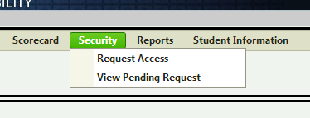

- Click Search to see all of the request that are pending.
- You will see each person who has requested access. Click View Access Request to proceed.
- At this point, you will want to select Approve (if you deem the request appropriate).
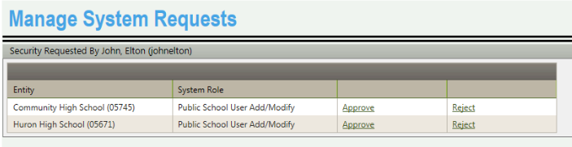

- Next, the Add User Security will be displayed. At this point, you will need to enter a profile name in the Enter Profile Name box. Please see the conventions for naming profiles below.
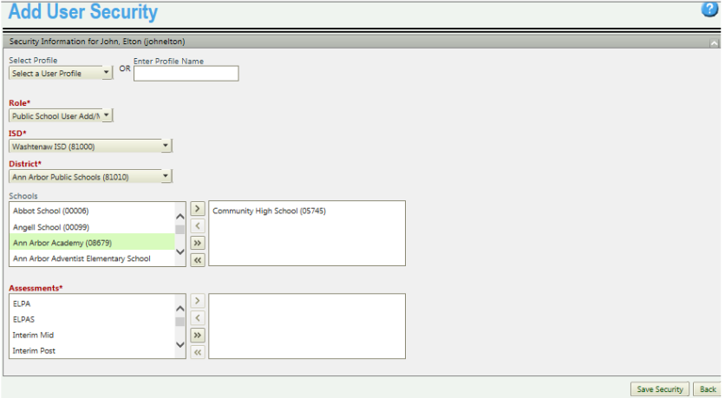
ISD Employee | Profile Name | Access Requested
Mitch Fowler | Data Consultant (District Name) | District Accountability  District User View Only Assessment
Joe Liberato | DCIA Consultant (District Name) | District Accountability  District User View Only Assessment
Ann Walton | CISD SPED (District Name) | District Accountability  District User View Only Assessment

In addition, you will need to select a Role (this will default to what role was requested). Select the ISD, District, and Schools (if necessary). Finally, select the button to provide the requestor with access to all assessments.
At this point you have granted access to the individual requesting access. However, you are not done. You will need to add the additional role requested. For example when Mitch Fowler requests District Accountability Access, you will need to follow the steps above to grant this access. Additionally, you will need to separately grant District User View Only Assessment access. This cannot be done with the first request.

Adding Additional Roles to a User
- Select Admin Functions > Security – Manage User Profiles
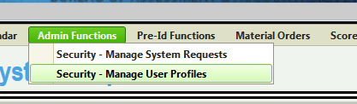
- Click Search to view all users.
- Select Update Security
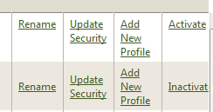
- Select your new role, ISD, District, and Schools (if appropriate). Select the button to move all assessments to the right. Click Save Security.
