MEAP Students with Disabilities Data Dig Protocol
Materials Needed:
- Access to MI School Data Secure Site
- Excel (or alternative spreadsheet/graphing software)
Part 1 – Download Data from MI School Data
- Visit https://www.mischooldata.org and login. If you do not know your password, please contact your technology department.
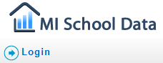
- Once logged in, scroll down to the bottom left and click on Data for Student Success.
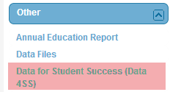
- Select the Comparative Item Analysis.
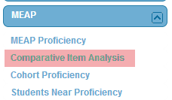

- Use the dropdown menus to select your ISD, District, and School.
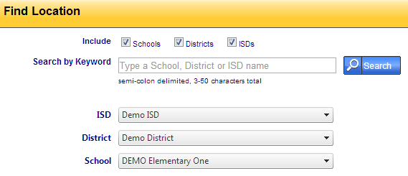
- Choose your report settings and click View Results.
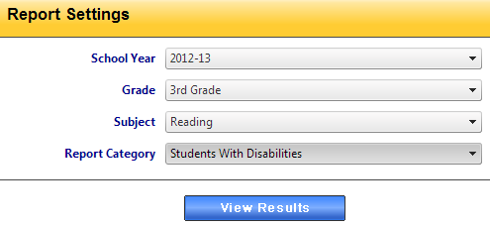
- You are now viewing state and school level data on the strands that were assessed for the assessment you selected in Step 5. Scroll to the bottom of the screen and click Export to CSV.
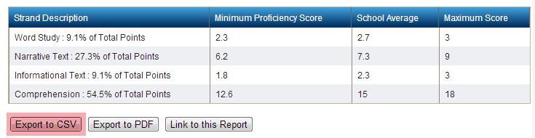
- Open the Excel file and save it. I have found that creating a folder such as 3rd Grade MEAP Reading can help organize the information you’ve downloaded. In addition, naming the file with the year (2012-2013 3rd Grade MEAP Reading Strands) can further help to organize your files.
- Return to MI School Data and click on Inquiry Settings. Change the report settings to run a report for the previous year. Download and save the previous year’s strand data in the folder you just created.
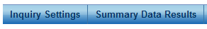
- Once completed, your 3rd Grade MEAP Reading folder will look like this:
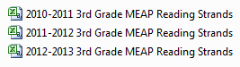
- Repeat the process above for other subject areas you wish to analyze.

Part 2: Combining and Analyzing Multiple Years of Strand Data
- With all MEAP Strand documents open, copy and paste them so that they are all on the same tab. It should look like this:
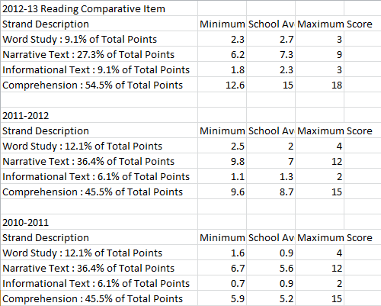
- Label the tab at the bottom so that you’ll know that tab is for Strand level data.

- Now that you have multiple years’ worth of strand data, let’s take a look at the % correct at the school and state levels. To do this, add the columns identified in pink below.
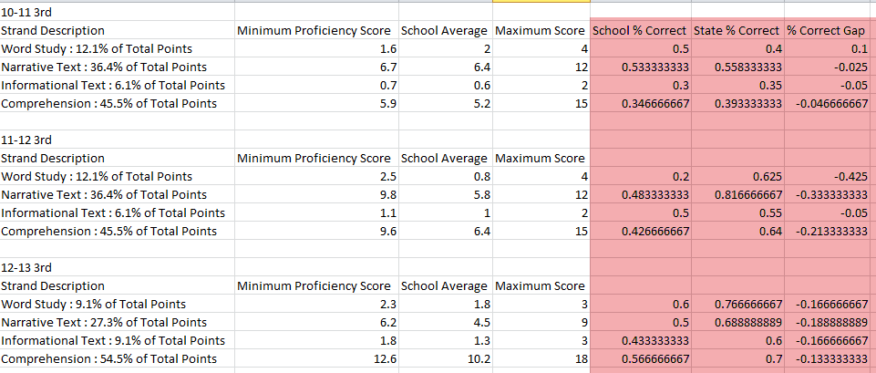
To have Excel calculate the percentages for you, type the following in the cell:
= Cell 1 / Cell 2
For example, I was able to calculate School % Correct (Cell E3) below, by typing the following in Cell E3: =C3/D3
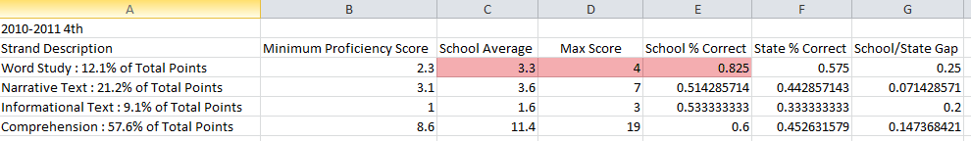
You can repeat the process for other cells as appropriate.
- Next, calculate the difference between your school’s performance and the state’s performance (the state’s performance is the “Minimum Proficiency Score” column). To do this, we’ll type the following in Cell G3: =E3-F3

- At this point we have identified how the school has performed on the strands assessed and compared this performance to the state. This data can help us determine the strands where a school is performing far above or below the state, which could be an area to focus on. However, before making this decision, it’s important to get a feel for the blueprint, or makeup, of the test.
Part 3: Identifying the Blueprint of the Assessment
- I have found that creating a visual of the blueprint can help identify which areas you’ll get the most bang for your buck when it comes to addressing low areas. To do this, create a column to the right of your strand level data from Part 2. In one column put the Strand names. You can see below that I’ve included Word Study, Narrative Test, Informational Text, and Comprehension. In addition, I put the % of points in the column next to each strand name. For example, Word Study = 12.1%.
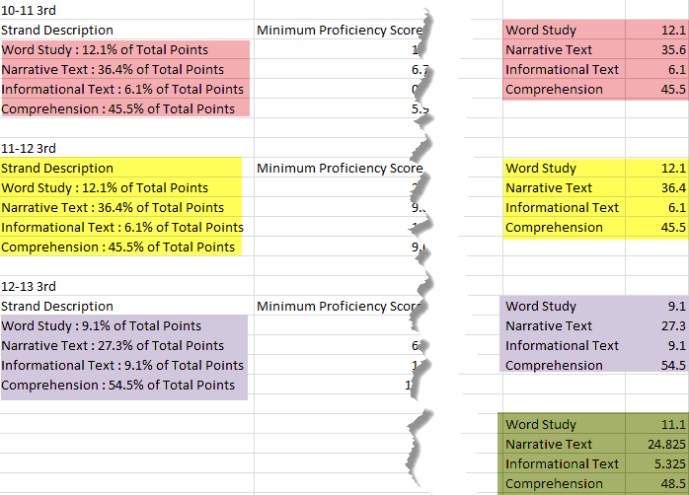
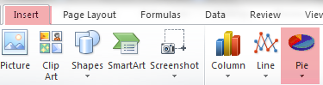
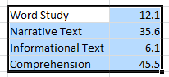
- Next, we’ll create a pie chart for each year’s strand data. To do this, highlight the strand labels and the corresponding %, select Insert, and choose the Pie Chart.

- You can select the format of the pie chart by using the choices I’ve highlighted below.
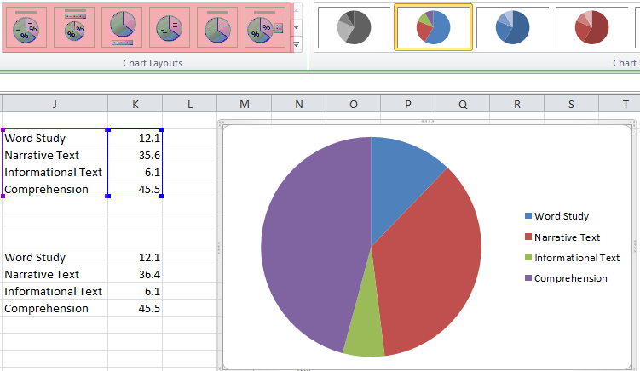
- Repeat this process for the remaining years. In addition, you might choose to find the average for all of the years to show trends. To do this, add two columns (they are the columns in green on Step 1 above) and use the following syntax to have Excel calculate the average:
= average (Cell1, Cell2, Cell3)

- Finally, review the strand data to determine which areas of the assessment are weighted heavier than others. In our example below, it’s clear that the Comprehension Strand (pictured in purple below), makes up the vast majority of the test. It goes without saying that implementing a strategy in Comprehension would cover the largest portion of the assessment. In the next step, we’ll take a look at how to determine which Comprehension GLCEs have been assessed and where you may need to focus efforts.
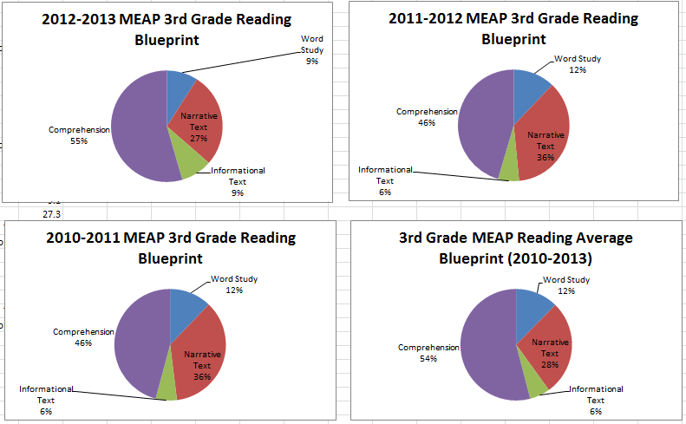

Part 4: Download GLCE Data from MI School Data
- Return to MI School Data and the graph we accessed in Part 1, Step 6. Since we now know that Comprehension is the largest portion of the test, we’ll dig into the Comprehension questions to determine specific areas of weakness. To do this, click anywhere on the Comprehension bar.
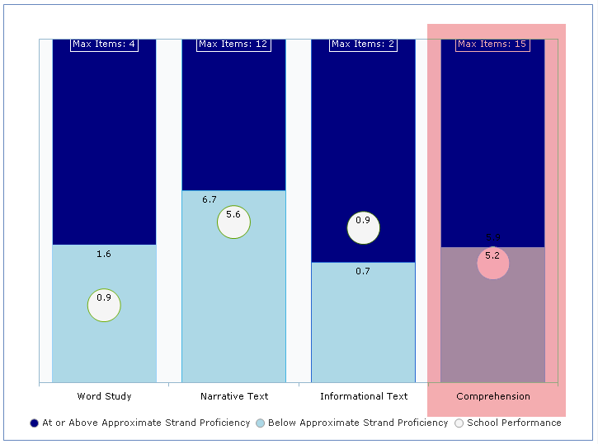

- When you click on the strand bar, you will see a graph and a chart. The graph shows each item, the performance of students with disabilities (SWD) and all except disabilities (AED).
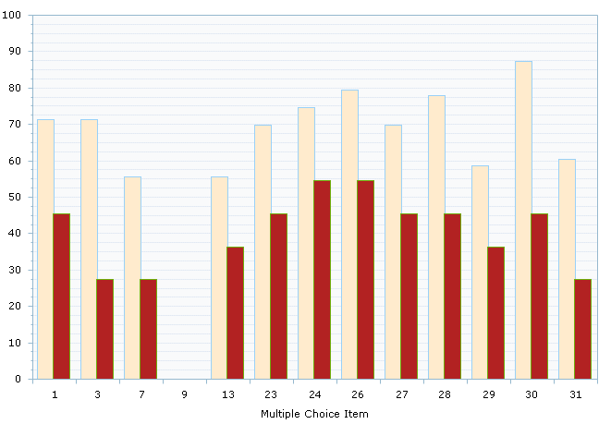
The table breaks down each question, provides the SWD % correct, AED % correct, the gap between the two, GLCE assessed, and GLCE wording. Click the Item Gap % header to sort the column from largest to smallest gap.
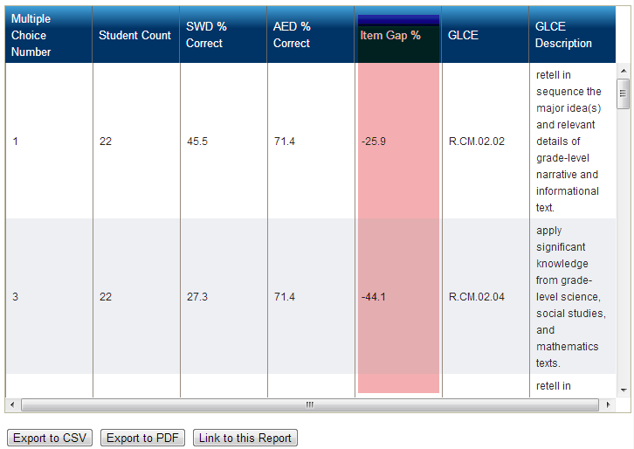
- Click the “Export to CSV” button and save the file in the folder you made previously. I recommend saving the file with the following conventions:
  - 2012-2013 3rd Grade MEAP Comprehension GLCEs
  - 2011-2012 3rd Grade MEAP Comprehension GLCEs
  - 2010-2011 3rd Grade MEAP Comprehension GLCEs
- Repeat the process above for the two previous year’s Comprehension GLCE data.

Part 5: Combining and Analyzing Multiple Years of GLCE Data
- Now that you have downloaded the individual GLCE files, we will add them to the Strand Data with a new tab. At the bottom of your Strand Workbook, add a new tab. I’ve called mine 3rd Item Level.
- Copy the data from the previous section and paste it so that you have multiple years of GLCE data. I setup my Item Level tab so that I have 2012-2013 Comprehension GLCEs listed, then my 2011-2012, and then 2010-2011. If you choose, you can also add other GLCEs from other strands to look for patterns using this format.
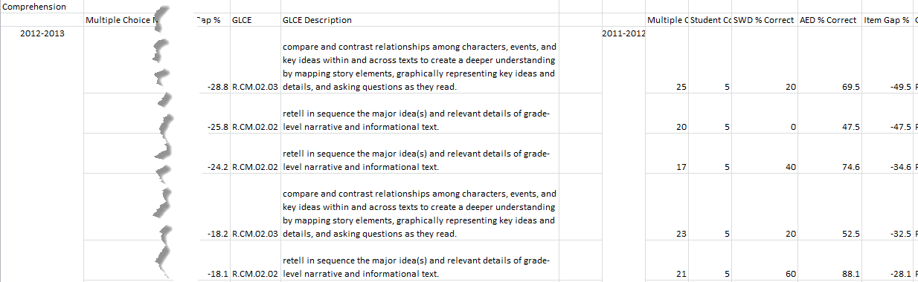
- The next step will help us determine if the same GLCEs have been assessed over multiple years. Add another tab at the bottom of your workbook. I have named mine 3rd Item Level Graphs.

- On your new tab, set up a table that mirrors what I have below. You’ll see that I’ve listed any comprehension GLCE that was assessed between the three years. I found R.CM.02.03, R.CM.02.02, and R.CM.02.04.
Next, I created a column called “Total Items”. Here, I simply counted how many Comprehension items were on the assessment for the year. After Total Items I have # of Items. This column identified how many times the specific GLCE showed up in that year’s assessment. Finally, I used the GLCE % column to calculate what percentage of the strand was from the selected GLCE. I repeated the process for the remaining years.

- The last step in this phase is to add a visual to the data. To do this, select the GLCEs on the left, hold the Ctrl button and select the corresponding year’s GLCE %, click Insert, and choose the pie chart. This step is similar to Part 3 Steps 2 and 3.
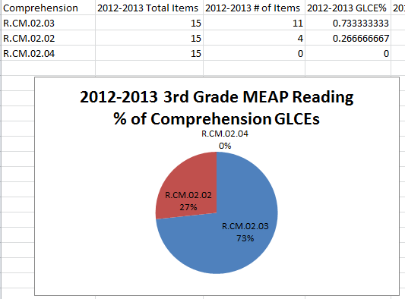
- Now that you’ve identified the Comprehension GLCEs and their relative weight for three years, determine if there are consistently high-weighted GLCEs. Based on my example, it’s clear that R.CM.02.02 and R.CM.02.03 are the most prevalent GLCEs that make up the largest portion of the 3rd Grade MEAP Reading assessment.
GLCE | GLCE Description
R.CM.02.03 | compare and contrast relationships among characters, events, and key ideas within and across texts to create a deeper understanding by mapping story elements, graphically representing key ideas and details, and asking questions as they read.
R.CM.02.02 | retell in sequence the major idea(s) and relevant details of grade-level narrative and informational text.

Part 6: An Alternative View of the Data with Wordle
Another way to view this data is to use the free tool, Wordle. Wordle is located at http://wordle.net and is a great way to make a word cloud out of selected text. In this example, I am going to take the text of the common GLCEs that were assessed and paste the text into Wordle. When I do this, I get the following:
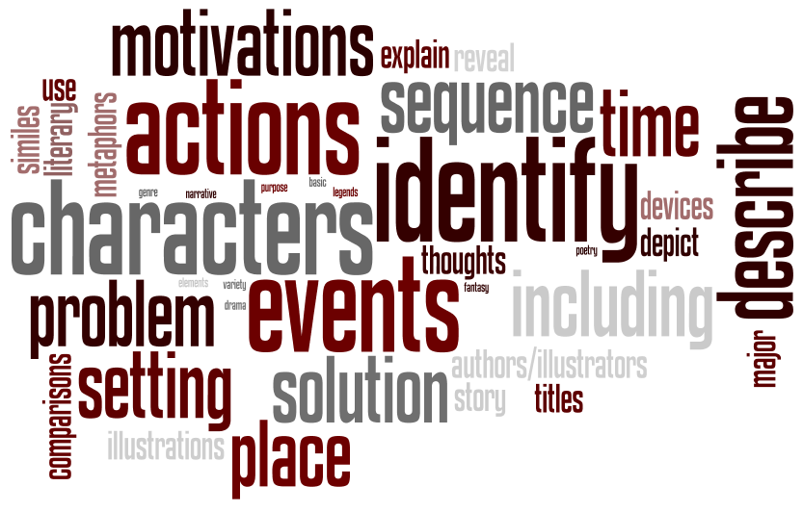
A quick peek at the word cloud show that words such as “identify”, “characters”, “events”, “actions”, and “motivations” are high frequency words within the text I’ve pasted. I know this because the words are larger; the more frequent the word, the larger the text.

