MI School Data Special Education Focused Activities
5 Year Proficiency Trend Analysis
1. Select Student Testing and the Assessment to analyze.
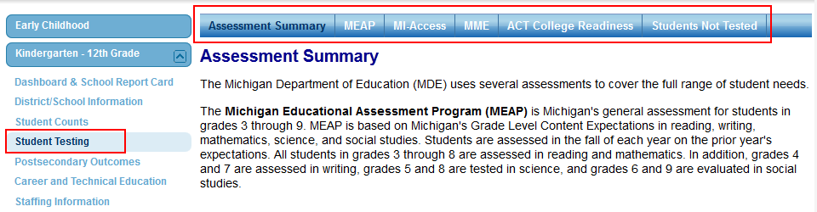
2. Select your location from the Find Location section. Select the School Year, Grade, Subject, and Students with Disabilities from the Report Settings section. Click View Results.
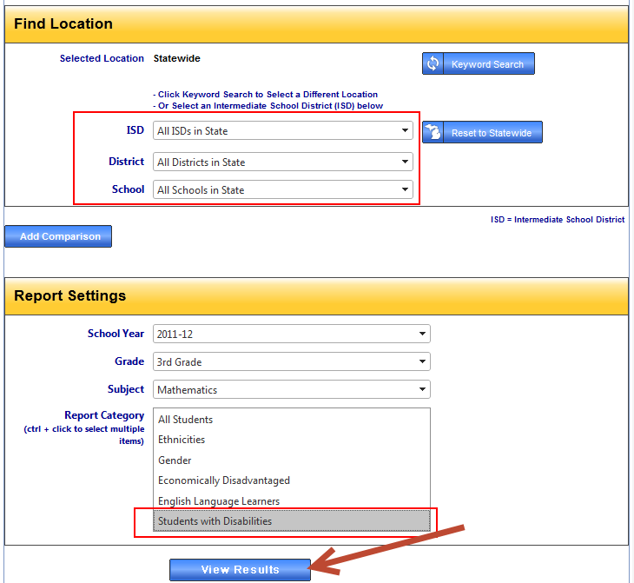

3. The results are displayed in a graphic format. To view the trend, click the Trend radial button.
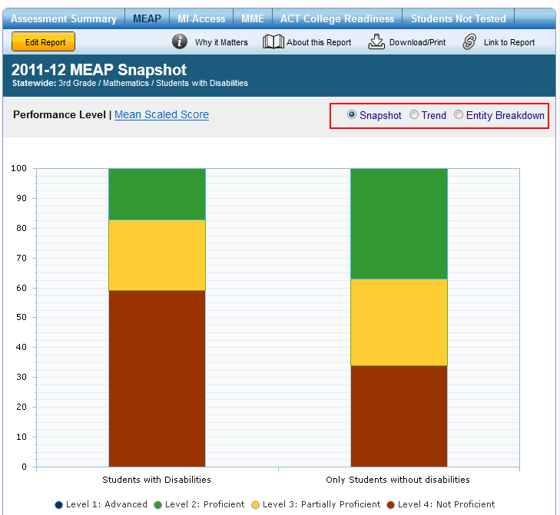

4. The trend results are displayed in a line graph and tabular format.
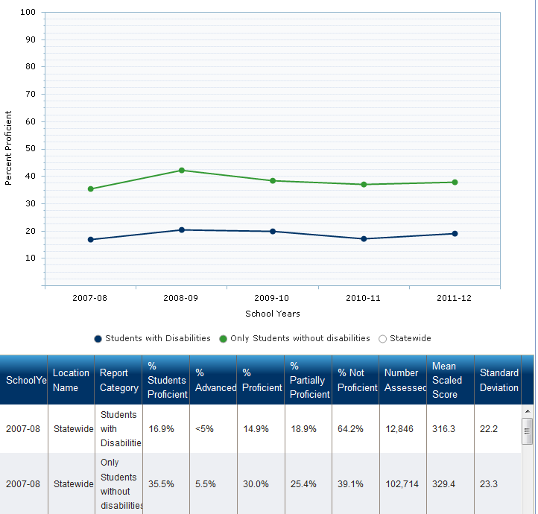

5 Year Proficiency Trend Analysis - Activity
Using the directions above, describe the 5 year trend in Math and Reading with a selected school.

5 Year Trend Statement for Math

5 Year Trend Statement for Reading

MEAP/MME Item and Strand Analysis
1. To access these inquires, you will need a MI School Data Login. Once you're logged in select Data for Student Success (Data 4SS).
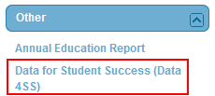
2. Select the analysis you would like to use.
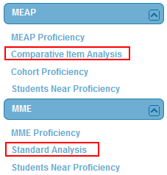
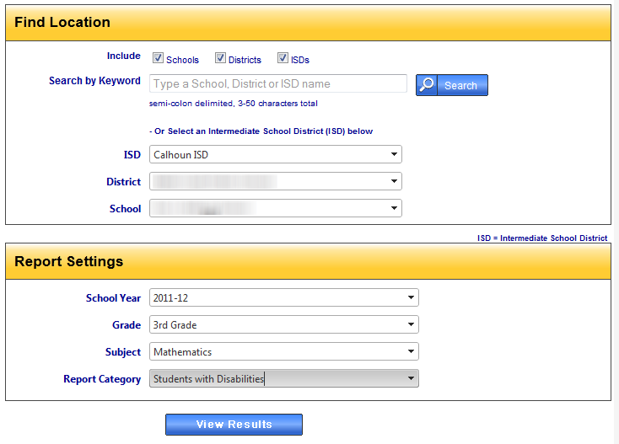
3. Select your location, choose your school year, select a grade, subject, and choose Students with Disabilities in the Report Category. Click View Results.

4. The results will be displayed in the following graphic. The graphic displays the strands that were assessed within the selected assessment subject. The light blue portion of the bar displays the minimum proficiency score within the strand. The white circle displays the building average. For example, within the Addition Subtraction Fluency Strand (23 potential question), students needed to receive 16.6 points to be proficient within the strand. However, the building average was 10.2. To dig deeper into this strand, click the light blue portion of the bar graph.
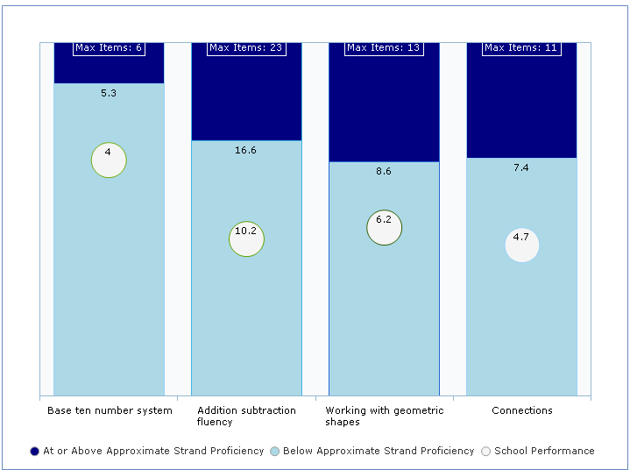

5. Digging into the strands will yield the following report. This report shows users which questions on the assessment were aligned to the selected strand. The graph shows the % of students responding correctly for each question (students with disabilities vs all except disabilities).
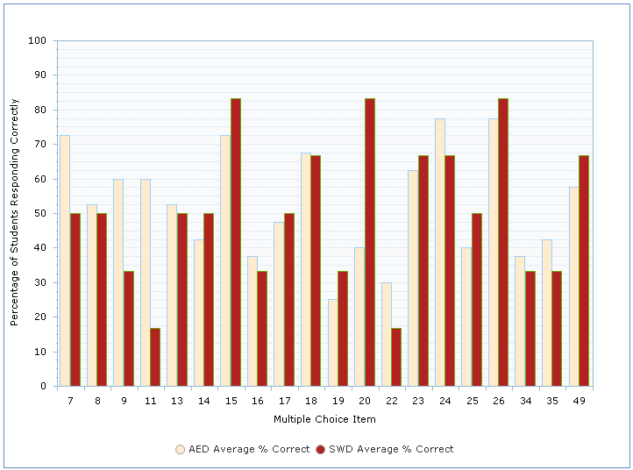
6. The results are also displayed in a tabular format. The table shows the details, in particular the Item Gap% , GLCE, and GLCE Description.

MEAP/MME Item and Strand Analysis - Activity
Using the directions above, identify the largest gap in the lowest strand of the Math and Reading assessment of your choice.
Lowest Math Strand

Largest Math GLCE Gap

Lowest Reading Strand

Largest Reading GLCE Gap

