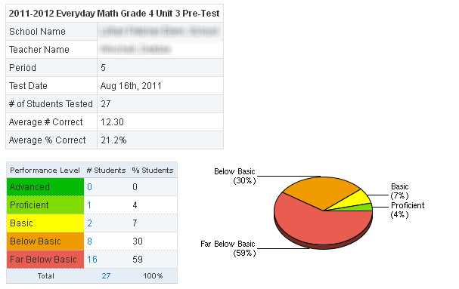

**PROM/SE PD**

**Sample Pre Test Classroom Exam Report**

**This report was used to complete the data conference planning document featured in the PROM/SE teacher and administrator PD.**

