MI School Data Proficiency Inquiry Activity

For this activity, you will need to access the Proficiency Inquiry on MI School Data. In the Report Settings section, change the Report Category to Disability Type and the Disability Type to All Disabilities and click View Results.

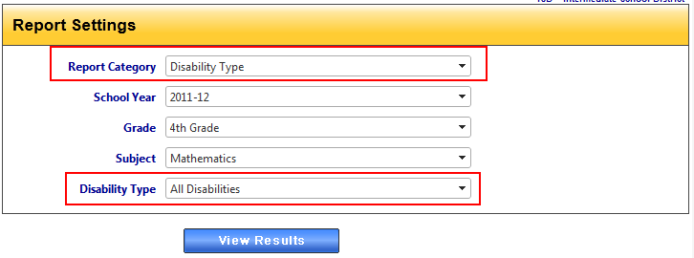

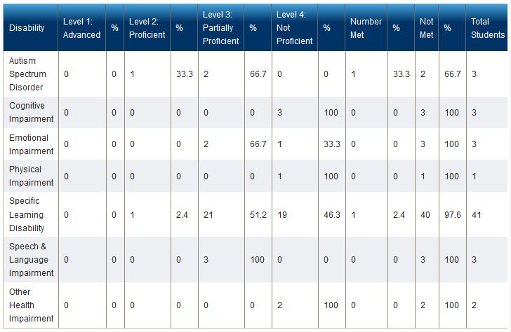
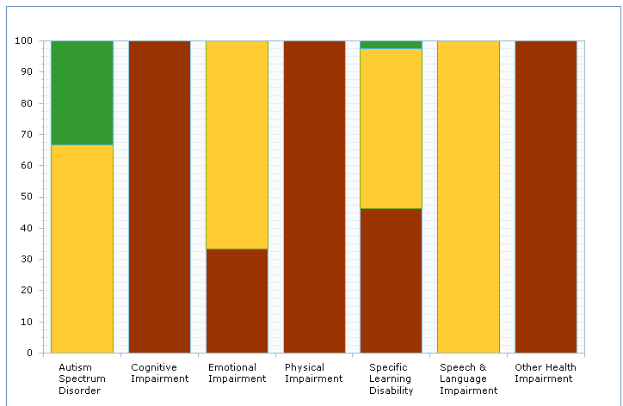
After clicking View Results, you will see the data in a graphic and tabular format.

Disability | 11-12  % Met District | 10-11  % Met District | 09-10  % Met District

Questions for Data Analysis:

- What is the trend in achievement for this MEAP test? Does each disability group share the same trend?
- Should more attention be focused on certain disability groups?
- Which subgroups performed the best on this test? Worst?

